TIMS 3311 ASSESSMENT 2
Critical Reflection Essay + Reflective Diary Entries
Completed by: Ruby Gilmour Tenorio
s48005100

PART 1: The Overall WIL Experience

New things I learned about myself
The overall WIL experience has been a deeply insightful and, at times, challenging journey of self-discovery. At the beginning of my WIL placement with Eclipse, I felt slightly apprehensive about navigating a biotech venture as I possess limited knowledge of the biotechnology space. However, it soon became apparent that my team and I would be on the forefront of customer discovery, conducting ‘on-the-ground’ research and applying design thinking and lean startup tools to generate, test and refine early-stage insights. Through these activities, I learnt that I thrive in structured ambiguity, where I can navigate uncertainty through iterative problem-solving and effective teamwork. This also showed me that I’m more adaptable that I initially thought.
Highlights and difficult times
A personal highlight of my journey with Eclipse was conducting a problem interview with Rachel, a beauty retail specialist at Mecca Cosmetica. Throughout our discussion, she mentioned that clients over 30-40 years old seek anti-aging products and are willing to spend “$500 on a single face cream”. This was a shocking discovery for me, and I immediately recognised a high-value market niche that a premium ingredient like lactoferrin could successfully serve. It felt like a lightbulb moment where I realised that I could contribute meaningful commercial insight even in a field I initially felt underqualified in.
Nonetheless, I experienced a key difficulty being unable to attend the weekly Eclipse meetings with Siobhan due to a class clash. This meant I only received the insights that were later relayed to me and lacked the opportunity to ask Siobhan questions that were meaningful to me. As well, it contributed to a slight feeling of disconnect from Siobhan’s entrepreneurial mindset and vision.
How I dealt with challenges
However, my teammates were extremely proactive in ensuring that at least one of us was in weekly attendance and taking meeting notes to later distribute to the rest of the team via Instagram messages and Google Docs. Additionally, we would request team meetings regularly to ask clarifying questions and ensure that we were all in task alignment. Overall, I felt supported by my team members, despite my absence in the weekly Eclipse meetings, and that helped me stay connected to the project’s progress and feel included in decision-making.
What I would do differently in hindsight
In hindsight, I would take on a more proactive and professional attitude to the WIL experience. Whilst I have been hands-on throughout the entire journey with Eclipse, I feel as though I could have tried to connect with Eclipse collaborators, whether with other members of Eclipse’s team or, simply, the other WIL students partnered with Eclipse. These conversations could have provided alternative perspectives on customer discovery and product positioning that my immediate team might not have considered. I believe that building these connections would have strengthened my industry awareness and, therefore, offered long-term professional benefits.
Specific networks built
In saying that, the networks that we did establish were meaningful and purposeful. We were consistently in close contact with Siobhan either through email or Zoom meetings, providing firsthand exposure to biotech entrepreneurship. Within some of these meetings, the second cosmetic team for Eclipse was present and exchanged similar strategic insights. Moreover, the interviews we conducted opened channels of conversation with retail professionals which expanded my understanding of how ingredient credibility shapes B2B partnerships. Finally, we engaged in frequent dialogue with our WIL tutor, Jack, whose feedback helped translate theory into practice throughout the Eclipse project.
Value derived beyond surface-level benefits
Connecting these networks helped me understand how cross-disciplinary expertise ultimately drives innovation. Beyond these benefits, I found personal value in the leadership and initiative skills I acquired, in which I learned that entrepreneurial decision-making is made easier through one’s self-efficacy in navigating ambiguity, asking the right questions and translating feedback into actionable learning for venture growth.

PART 2: New Knowledge, Insights, and Skills

The past
Prior to the WIL experience, I had developed a rich understanding of entrepreneurship. This is attributed to my previous semester of study within the Innovation and Entrepreneurship major, where topics such as Lean Startup, Customer Discovery, Business Models and more alike, were explored extensively. These foundational courses provided me with theoretical perspectives and a basic understanding of startup ecosystems. For example, in my Entrepreneurial Mindset and Ideation (TIMS1301) class, I was tasked with a customer discovery assignment where I had to conduct two in-depth interviews on a pressing and unmet consumer demand. This equipped me with early skills in problem identification and stakeholder communication although I struggled with translating insights into practical initiatives. Ultimately, this contributed to my anticipation for this WIL course as it presented the chance to build on my existing skillset and experience the complexities of startup development firsthand.
Key learnings
Effectuation, as described by Sarasvathy (2022), ‘is a logic of non-predictive control’ grounded in the idea that entrepreneurs can act despite uncertainty by focusing on what they can control rather than what they can forecast. This guided my team’s early approach to Eclipse as there was great ambiguity about market fit and consumer applications of lactoferrin. The first process of effectuation we employed was the Bird-in-hand principle through a means inventory. We recognised Siobhan’s biotech expertise, successful funding initiatives and Eclipse’s QUT lab networks as opportune starting means that guided how we defined feasible pathways for market validation.
Another effective process we implemented was the Crazy Quilt principle whereby entrepreneurs ‘bring in others to co-create the future’ (Sarasvathy, 2022). Our stakeholder exchanges with Siobhan, Jack and retail professionals created a rich co-learning environment wherein the consolidation of varying viewpoints helped us identify the most advantageous entry point for Eclipse. These principles were the most instrumental in guiding my journey with Eclipse and will continue to shape my professional growth by reinforcing effectual logic as a mindset for innovation and venture creation.
Moreover, the lean startup framework as defined by Ries (2011) to be ‘a systematic approach to testing hypotheses about product, customer and market fit’ was integral to our iterative testing process with Eclipse. In particular, the build-measure-learn feedback loop helped us ‘turn assumptions into knowledge’ (Ries, 2011). Initially, my team and I had assumed that the scientific novelty of lactoferrin would drive consumer interest, specifically for the B2B route as reputable brands value differentiation.
The business model canvas (BMC) mapped out this assumption, capturing the key partners and customer segments most likely to adopt biotech-backed ingredients in premium skincare, and forming the build stage of our feedback loop. Interestingly, when measuring our hypothesis through problem interviews, the responses revealed a demand for hydration and brand trust over scientific novelty. As Blank and Dorf (2020) reminds us, ‘learning that a hypothesis is wrong is not a crisis’, rather a critical step toward refining understanding. This reflection marked the learn stage of the feedback loop, where insights from real customer data replaced assumptions and informed our next iteration. In future innovation roles, I will apply this iterative logic to prototype emerging technologies.
Furthermore, design thinking encouraged me to look beyond surface-level preferences and uncover the emotional drivers behind consumer behaviour. Liedtka and Ogilvie (2011) define this concept as a ‘systematic approach to problem-solving that starts with customers’ and thrives on ‘empathy, invention and iteration.’ An empathy map was created for each demographic – women, men and retail professionals – to compare their purchasing behaviours and underlying motivations toward skincare. We discovered that women sought hydration, men valued convenience, and retail staff prioritised scientific credibility. By synthesising these distinct motivations, a clearer market demand emerged, allowing Eclipse to define a more competitive entry point.
This process was particularly enlightening because I learnt that a successful innovation requires learning how users think, feel and decide in order to position the venture at the intersection of user desirability and market opportunity. For future roles in consulting or innovation, design thinking can aid in ‘understanding the human context behind a problem’ (Liedtka & Ogilvie, 2011) and, ultimately, drive value creation.
The future
This WIL experience has reshaped how I view innovation and entrepreneurship. The intricacies involved in venture creation, such as navigating uncertainty, iterative testing and customer discovery, have refined my approach to creating meaningful innovation. I’ve developed transferable skills namely, adaptability, leadership and critical problem-solving skills, that can help me seamlessly adjust to a career in technological innovation, as I wish to pursue after graduation. In reflection, I am grateful for the behind-the-scenes exposure this WIL has provided, as it has inspired a stronger belief in my ability to launch my own venture in the future.
Course feedback
Beyond the real-world startup exposure, I valued learning to think and act with the adaptability of an entrepreneur. Stepping into that role as a “market specialist” made the experience feel legitimate and personally rewarding. If I were to suggest three specific improvements, the first would be to allocate more on-campus class time. It would be interesting and beneficial to converse with the class throughout their startup journeys and exchange advice, fair dues and constructive feedback. Next, a mentoring session with UQ Ventures would be a valuable addition because it makes entrepreneurship feel local, visible and achievable. My final suggestion would be for the groups to be pre-assigned rather than allowing self-allocation to promote diverse collaboration and push us beyond familiar working styles.
WORD COUNT (excluding headings): 1,499

Reference List
- Blank, S., & Dorf, B. (2020). STARTUP OWNER’S MANUAL : the step-by-step guide for building a great company. John Wiley.
- Interaction Design Foundation. (2024, January 1). What is Design Thinking? — updated 2023. The Interaction Design Foundation. https://www.interaction-design.org/literature/topics/design-thinking#docs-internal-guid-273153d1-7fff-ce78-a109-51555111902a
- Liedtka, J., & Ogilvie, T. (2011). Designing for Growth: A Design Thinking Tool Kit for Managers. Columbia Business School Publishing.
- Ries, E. (2011). The Lean Startup | Methodology. Theleanstartup.com. https://theleanstartup.com/principles
- Sarasvathy, S. D. (2022). Effectuation. Elements of Entrepreneurial Expertise New Horizons in Entrepreneurship Series. https://doi.org/10.4337/9781839102585

Reflective Diary Entries

Entry 1 — Getting Started (Weeks 1–2: Means Inventory & Orientation)
Partnering with Eclipse, as part of this Work Integrated Learning (WIL) course, introduced my team and I to an incredible learning experience, throughout which I have progressed through distinct stages of professional and personal growth. At the outset of joining the Eclipse project I was both intrigued and confused about the biotechnology and precision fermentation that the company was exploring in lactoferrin. It became critical to delve deeper into Eclipse’s background and value proposition to understand why and how my team and I could effectively contribute to the company’s projected success.
Thus, we began with a Means Inventory to map out Eclipse’s existing resources, networks and expertise. We believed this approach to be a valuable starting point given the exploratory nature of Eclipse’s current market position. Completing the Means Inventory aligned closely with Sarasvathy (2022)’s discussion of effectuation theory, especially the bird-in-hand principle, which suggests that entrepreneurs ‘design possible effects using a particular set of means’ rather than chasing fixed outcomes. Sarasvathy (2022)’s evaluation also reiterates that ‘effectuation is useful at points where goals are ambiguous and equivocal’ which captures the uncertainty Eclipse faces in defining its market direction.
As part of Eclipse’s skincare-focused team, we discovered that the company was rich in available resources and connections. These included Eclipse’s start-up CSIRO funding and connections with QUT laboratories as well as a diverse and expanding team of strain engineers, scientists, and Siobhan’s (Eclipse CEO/Founder) personal expertise in food health alongside business and commercial roles. With this understanding, our role as “market specialists” feels particularly valuable and strategically significant.
Ultimately, this first step offers a clear understanding of Eclipse’s strengths and sets a strong foundation for my team and I to pursue meaningful research into which markets and demographics would best align with its resources.
Entry 2 — Structuring Direction (Weeks 3–4: Business Model Canvas)
Our entry point is to incorporate lactoferrin in skincare through B2B partnerships as discussed with Siobhan, which is a promising market however value spans across many demographics. To help bring structure to this entry, we have been creating a business model canvas (BMC) which helps to identify and organise the key factors involved in positioning the business effectively.
In our first conversation with Siobhan, we reached a decision to target existing cosmetic manufacturers who already occupied a reputable position in the market. There was discussion about whether this partnership would be with mainstream brands such as Cetaphil or La Roche Posay, or premium and luxury brands seeking novel active ingredients. Our BMC is corroborating these considerations in assuming that Eclipse’s resources, such as their R&D capabilities, founder networks and brand credibility, will provide a strategic indicator as to which key partners, customer segments and channels are most favourable and sustainable.
After our team meeting, we have decided to focus on premium skincare brands as lactoferrin is a highly unique ingredient with anti-aging effects, making it reasonable to assume that these brands would value its scientific credibility and differentiation potential. Therefore, our next progression is to treat this as a hypothesis to be validated through research and upcoming problem interviews, aiming to confirm if lactoferrin’s skincare benefits and scientific novelty align with market demand. Notably, the BMC guided this decision-making under uncertainty and made me more aware of the clarity that can emerge through iteration and collaborative learning. It led to a sense of confidence in our decision as it was based on evidence and extensive research rather than guesswork.
Entry 3 — Validating the Problem (Weeks 5–6: Problem Interviews)
After mapping the BMC, we moved to validate whether the pain point we’d identified actually exists. Our targeted reach was 30 end-consumers ranging from women aged 16+, to men who are and are not active skincare users, to aestheticians and beauty retail workers. This encouraged diversity across the responses and was in alignment with Siobhan’s request to broaden demographic representation.
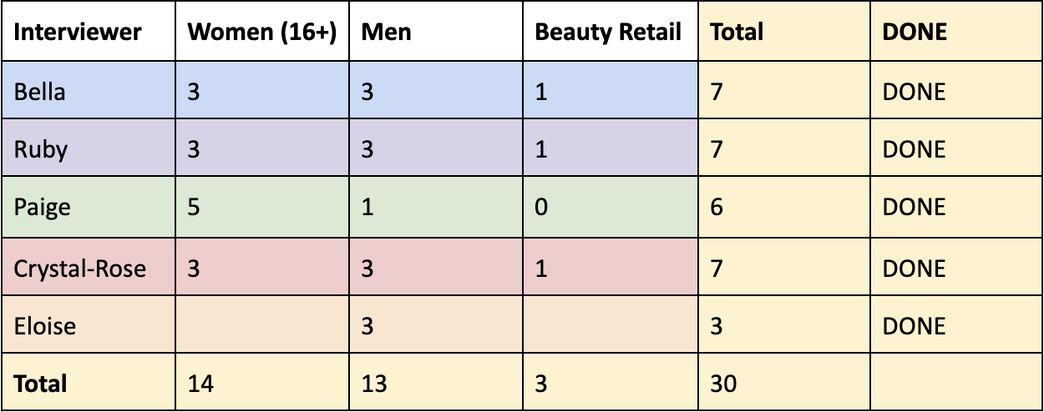
Table 1. Team coverage across 30 interviews
As observed in Table 1. I conducted 7 interviews across the three demographic segments. During my first interview, I noticed the questions were repetitive and unintentionally prompted specific responses. For instance, one question asked, “When does a product feel like “good value” to you - is it the price, the results, or something else?” I became aware that this phrasing was inadvertently shaping the interviewee’s responses. Before moving onto a second interview, I mentioned my concerns to the rest of the team during a team meeting. At that point I was made aware that Siobhan corroborated this notion, as seen in Figure 1., and suggested to keep the questions open, allowing insights to emerge naturally.
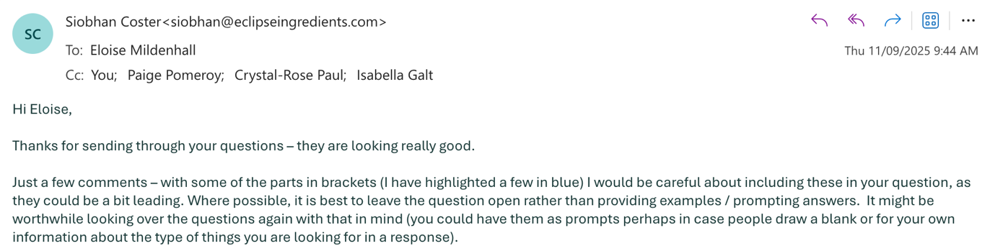
Figure 1. Email feedback from Siobhan
We revised the questions accordingly, giving way to detailed and meaningful responses from the remaining participants. This reiteration was the critical turning point in our assessment of Eclipse’s value proposition and demonstrated, to me, the importance of listening for behaviour, not hypotheticals. This process also reflected an early application of Lean Startup’s ‘build-measure-learn’ cycle, not through a physical MVP, but through iterative testing of customer assumptions. We were able to build a hypothesis around lactoferrin’s potential appeal, measure its validity through authentic customer responses and learn which needs were most consistent across demographics (Ries, 2011).

Entry 4 — Understanding the Consumer (Weeks 7–8: Empathy Mapping)
By week 7 our interviews were mostly completed so we began empathy mapping. Empathy mapping is the first stage of the design thinking process, ‘a non-linear, iterative process that teams use to understand users, challenge assumptions, redefine problems and create innovative solutions to prototype and test’ (Interaction Design Foundation, 2024). Thus, in understanding the consumer, we built empathy maps for women, men and retail professionals, highlighting what the participants say, think, feel and do.
Our working hypothesis was that lactoferrin presented a highly valuable and unique product offering to users seeking anti-inflammatory, antimicrobial and anti-aging benefits. Each demographic revealed unique insights, with women desiring hydration and visible results, men concerned mostly with convenience and affordability, and retail workers valuing scientific credibility and proof of effectiveness. Observing each demographic’s needs in isolation made it easier to compare their pains and gains, as well as recognise commonalities between them. After team consolidation, we realised that trust and effectiveness were the most recurring needs.
This realisation challenged our initial assumptions that the science behind lactoferrin would be the main selling point. Instead, trust from brand legitimacy and observed results became the key drivers of perceived value. This finding reaffirmed the iterative nature of the lean startup cycle where validated learning emerges through continuous feedback rather than assumptions. This stage was particularly insightful as we unpacked why consumers make certain purchasing decisions and, therefore, helping me to recognise how understanding user motivations strengthens the fit between innovation and market reality.
Entry 5 — Measuring Real Reactions (Weeks 9–10: Survey Validation & Final Insights)
Approaching Week 13, my team and I have closed the survey after distributing flyers around campus and local networks for the past two weeks. 57 respondents answered a series of questions about their skincare priorities and preferences to help validate and refine our earlier assumptions. This is our second iteration of consumer research, designed to translate the qualitative insights from empathy mapping into measurable data trends that could guide Eclipse’s market positioning.
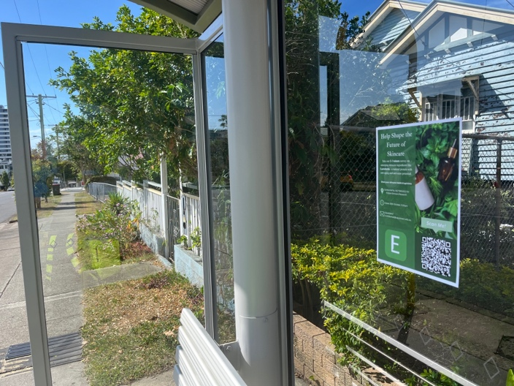
My involvement, thus far, has included putting up flyers across my local network, specifically bus stops as can be seen in Figure 2. This process of transforming qualitative insights into quantitative data is consistent with Ries’ (2011) lean startup principle that validated learning should precede strategic decision-making. I have learnt a valuable lesson from this process about testing ideas before committing resources and just how influential this validated learning cycle is. It has increased my ability to systematically reduce uncertainty and helped me to build transferable skills in research design and customer validation, both of which I did not possess before this WIL experience.
Figure 2. Bus stop flyer for survey promotion
Nearing the end of this journey, after communicating with a range of stakeholders, I feel more confident in speaking with new and diverse people and approaching unfamiliar situations with curiosity rather than hesitation; a mindset I’ll carry into future ventures and professional environments.

